**Image Categorization through Machine learning**

*Shabrina Sharmin*

Department of CSE

*Daffodil International University, Dhaka , Bangladesh*

shabrina15-12855@diu.edu.bd

**ABSTRACT :** During this paper we have witnessed some image classification techniques through machine learning. I will describe some image classification algorithms. First we will introduce machine learning and image classification. These are the algorithms like NN, QDA, RF, SVM, CNN, STIF.

I comparatively studied their performances. My main goal is to find a better method for image classification. We review some papers based on that topic. I found out that method using a performance measurement table.In that table AN SVM gives best performance.

**KEYWORDS**: *Machine Learning, Image Classification, Algorithms.*

**1 INTRODUCTION**

It is very surprising that an electronic device can recognize our face or any kind of object and how is this possible? It happens owing to machine learning. Machine learning is an associated algorithmic program set as we know that an algorithm is a formula for solving problems which is based on some specific problem [19] [3]. Therefore, it is suitable for any kind of prediction. We can always start with a data model but in its place, the machine learns the link between the reaction and its predictors by the utilization of algorithms [19]

Till today, there’s a desire to produce regional Land use and Land cowl that is thought as (LULC) maps for a variety of applications like landscape, change detection, etc. Remotely perceived photos supply quantitative and qualitative information that reduces quality and time of fortification and could be used for producing LULC maps through a technique noted as image classification [1-2] [5].

This method called image classification is also used in the medical field. Medical image information is made by imaging modalities. The problem of this field is that thanks to extracting the image and classifying the extraction result into the similar pattern then establish and perceive that parts of the anatomy unit of measurement full of the particular ill health from image classification result [4].

Image classification is the method of extracting valuable data from immense satellite imagery by categorizing the image element values into meaningful classes [1][14]. It includes pre-processing, image sensors, object detection, feature extraction and object classification [1]. The image organization consists of an information that contains predefined patterns which is compared with the associated object to classify to acceptable class [6] [3]. Two general methods of classification are supervised and unsupervised classification [2].

This paper aims to explore the way image classification works in machine learning.

**2 SEVERAL METHODOLOGIES**

In this topic many analysis papers are done.Every paper uses a typical topic that's supported by machine learning. Machine learning uses many algorithms like Regression, Logistic Regression, Decision Tree, SVM, Naive Bayes, kNN, K-Means, Random Forest, Surf.

First, we tend to aim to see the papers of Sehla Loussaief and Afef Abdelkrim. They used the SIRF detector of image Region of interest (ROI) and highlighted the unsupervised K-Means algorithmic program[2][19]. He chose SIRF instead of ScaleInvariant Feature remodel (SIFT) attributable to its apothegmatic descriptor length.

In STRF, It considers the grey level pictures solely as they contain a good amount of knowledge. K-means are utilized in order to cluster them and categorise them into clusters. In his experiment, he investigated several supervised learning algorithms like SVM, K-nearest neighbor, and Boosted Regression Tree to classify a picture.

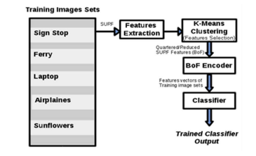

**Figure 1**: Image classification process[19].

After making a model this model takes a decision by the conclusion matrix [5].

In the paper of Siddhartha Sankar Nath, Jajnyaseni Kar they review the presently used technique in image classification. They review those algorithms based on some topic. Those are [5]:

* Based on the data non heritable from completely different sensors.
* Based on the character of the training sample utilized in classification.
* Based on the idea of assorted parameters used on data.
* Based on the character of pixel information used on data.
* Based upon the amount of outputs generated for every abstraction information component.
* Based upon the character of abstraction data.
* Special classification techniques.

In the paper of Erkan Deniz, Abdulkadir Şengür, Zehra Kadiroğlu, Yanhui Guo , and Varun Bajaj they work on cancer detection. They planned AN approach to discover cancer.By their planned approach they aim to find cancer efficiently from histopathology photos.They used a natural network technique called Convolutional neural networks (CNNs)[7]. CNN provides features extraction and classification with its end-to-end learning architecture.. CNN consists of many layers like convolution, pooling, standardisation, and totally connected layers. The training of CNN’s is usually disbursed with the conventional backpropagation algorithmic rule[7].

Transfer learning (TL) is outlined as transferring data that was learned earlier in one domain, to a different domain for classification and extraction functions. It uses the CNN model [7][5][9]. TL is employed to coach earlier on a bigger dataset.In the CNN models, edges, curves, corners, and color blobs-like options square measure learned within the initial layers, and therefore the final layers of the CNN models represent abstract and specific options. In their approach, the last 3 layers of the pre-trained CNN model specifically, absolutely connected layer, softmax layer, and classification output layer, square measure discharged and therefore the rest layers square measure transferred to the new classification task.

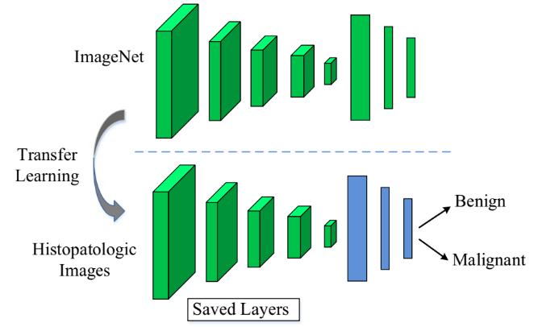

**Figure 2:** An iLLustration for transfer learning. The last 3 layers square measure counted as pre-trained CNN models and discharged and thus the rest of layers square measure used for latest classification tasks[7].

They conjointly used deep feature extraction. It's another style of transfer learning. it absolutely was used rather than the pre-trained CNN model[7][5][9]. deeper layers offer higher-level choices salient for image classification.

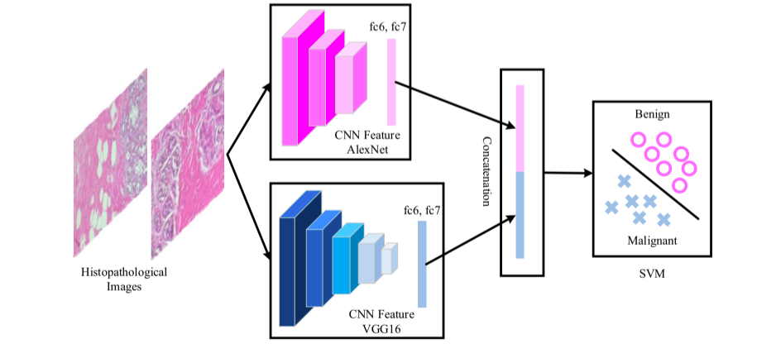

**Figure 3:** An illustration for deep feature extraction and SVM[7] classification. The fc6 and fc7 layers of the pre-trained CNN[7][5][9] models (AlexNet, Vgg16) square measure used for deep feature extraction.

The planned theme and design of CNN area unit illustrated in Figs. 1 and 2, severally. The input cancer histopathology photos unit of measurement fed into the pre-trained CNN models as seen in every figure. For feature extraction, pre-trained AlexNet and VGG16 models are used. The obtained choice vectors are then classified by AN SVM[7] classifier to check the class label of the input photos. For fine-tuning exclusively, the AlexNet model is taken under consideration.

Several methodologies have been used in those paper performance had been given bellow[6]:

| Methods | Accuracy (%) | | | |
| --- | --- | --- | --- | --- |
| 40x | 100x | 200x | 400x |
| NN | 81.9±1.0 | 79.7±1.4 | 81.5±2.7 | 79.4±3.9 |
| QDA | 82.8±4.1 | 81.1±3.9 | 84.2±4.1 | 82.0±5.9 |
| RF | 82.8±2.0 | 80.4±1.8 | 83.5±2.3 | 81.0±3.8 |
| SVM | 80.6±3.0 | 80.9±4.4 | 85.1±3.1 | 82.3±3.8 |
| CNN | 89.0±5.7 | 87.3±3.9 | 84.6±4.2 | 86.1±6.2 |
| AN SVM | 91.96±2.59 | 91.58±2.96 | 91.37±1.72 | 91.30±0.74 |

**3 COMPARATIVE STUDY BETWEEN MODELS**

In the previous section I reviewed some methods of some papers. Those papers are based on the image category . One paper uses different kinds of methods for image classification. After that they want to find out the best methods.Most commonly used methods are NN, QDA, RF, SVM, CNN, STIF [7][5][9][10][12]. Those are machine learning and Artificial intelligence based algorithms.

CNN models divide an image into several layers. Based on those layers it finds out the relation between objects. It’s a deep learning algorithm. If we saw our performance measurement table performance ratio of CNN[7] in between 89 to 86. This algorithm can figure out the image efficiently. Time complexity of this algorithm is linear.

When we look at other algorithms NN, QDA, RF, SVM those algorithms are based on machine learning algorithms[7] [10] [9]. Those algorithms perform in the range of 80 to 95. Those algorithms are quite complex. But performance is acceptable.

AN SVM[5](Support vector machine) gives best performance. Best thing about this model is its constant performance. But this algorithm has some disadvantages like, it requires full labeling input data, Solved model parameters are difficult to interrupt and this algorithm is directly applicable for two class tasks.

If we see all algorithm performance AN SVM[5] gives best performance.

**4 CONCLUSION**

In this paper I studied some algorithms and did some work in image classification that is already done by many researchers. All of those algorithms are AI and machine learning algorithms.My main goal is to search out the most effective algorithmic rule for image classification.I tried to study as much as I could to review papers. I read twenty two papers. In the paper of Ponnusamy, R., Sathyamoorthy and S. and Manikandan introduce some new techniques to optimize SVM algorithms and figure out best performance.

Overall AN SVM is best for image classification.

**Reference:**

[1] Ma L, Li M, Ma X, Cheng L, Du P, Liu Y. A review of supervised object-based land-cover image classification. ISPRS Journal of Photogrammetry and Remote Sensing. 2017 Aug 1;130:277-93.

[2] Nath, S.S., Mishra, G., Kar, J., Chakraborty, S. and Dey, N., 2014, July. A survey of image classification methods and techniques. In 2014 International conference on control, instrumentation, communication and computational technologies (ICCICCT) (pp. 554-557). IEEE.

[3] Miranda E, Aryuni M, Irwansyah E. A survey of medical image classification techniques. In2016 International Conference on Information Management and Technology (ICIMTech) 2016 Nov 16 (pp. 56-61). IEEE.

[4] Yang, L., MacEachren, A.M., Mitra, P. and Onorati, T., 2018. Visually-enabled active deep learning for (geo) text and image classification: a review. ISPRS International Journal of Geo-Information, 7(2), p.65.

[5] Ponnusamy, R., Sathyamoorthy, S. and Manikandan, K., 2017. A Review of Image Classification Approaches and Techniques. International Journal of Recent Trends in Engineering & Research (IJRTER) Volume, 3, pp.2455-1457.

[6] Salah, M., 2017. A survey of modern classification techniques in remote sensing for improved image classification. Journal of Geomatics, 11(1), p.21.

[7] Deniz E, Şengür A, Kadiroğlu Z, Guo Y, Bajaj V, Budak Ü. Transfer learning based histopathological image classification for breast cancer detection. Health information science and systems. 2018 Dec;6(1):1-7.

[8] Van den Elsen, P.A., Pol, E.J. and Viergever, M.A., 1993. Medical image matching-a review with classification. IEEE Engineering in Medicine and Biology Magazine, 12(1), pp.26-39.

[9] Ding, J., Cheng, H.D., Huang, J., Liu, J. and Zhang, Y., 2012. Breast ultrasound image classification based on multiple-instance learning. Journal of digital imaging, 25(5), pp.620-627.

[10] Lin CH, Chen HY, Wu YS. Study of image retrieval and classification based on adaptive features using genetic algorithm feature selection. Expert Systems with Applications. 2014 Nov 1;41(15):6611-21.

[11] Tsai DY, Lee Y, Sekiya M, Ohkubo M. Medical image classification using genetic-algorithm based fuzzy-logic approach. Journal of Electronic Imaging. 2004 Oct;13(4):780-8.

[12] Ohi M, Li Y, Cheng Y, Walz T. Negative staining and image classification—powerful tools in modern electron microscopy. Biological procedures online. 2004 Jan;6(1):23-34.

[13] Deepa, S.N. and Devi, B.A., 2011. A survey on artificial intelligence approaches for medical image classification. Indian Journal of Science and Technology, 4(11), pp.1583-1595.

[14] Pritt, Mark, and Gary Chern. "Satellite image classification with deep learning." In 2017 IEEE Applied Imagery Pattern Recognition Workshop (AIPR), pp. 1-7. IEEE, 2017.

[15] Agrawal S, Verma NK, Tamrakar P, Sircar P. Content based color image classification using SVM. In2011 Eighth International Conference on Information Technology: New Generations 2011 Apr 11 (pp. 1090-1094). IEEE.

[16] Cheng, Y.C. and Chen, S.Y., 2003. Image classification using color, texture and regions. Image and vision computing, 21(9), pp.759-776.

[17] Haralick, R.M., Shanmugam, K. and Dinstein, I.H., 1973. Textural features for image classification. IEEE Transactions on systems, man, and cybernetics, (6), pp.610-621.

[18] Manian, Vidya, and Marcel J. Castro. "Color Image Classification Using Gabor Filters." In Computing Research Conference Proceedings, May, 2000. 2000.

|  |
| --- |

[19] Loussaief, S. and Abdelkrim, A., 2016, December. Machine learning framework for image classification. In 2016 7th International Conference on Sciences of Electronics, Technologies of Information and Telecommunications (SETIT) (pp. 58-61). IEEE.

[20] Peña JM, Gutiérrez PA, Hervás-Martínez C, Six J, Plant RE, López-Granados F. Object-based image classification of summer crops with machine learning methods. Remote Sensing. 2014 Jun;6(6):5019-41.

[21] Popescu, M.C. and Sasu, L.M., 2014, May. Feature extraction, feature selection and machine learning for image classification: A case study. In 2014 International Conference on Optimization of Electrical and Electronic Equipment (OPTIM) (pp. 968-973). IEEE.

[22] Wang P, Fan E, Wang P. Comparative analysis of image classification algorithms based on traditional machine learning and deep learning. Pattern Recognition Letters. 2021 Jan 1;141:61-7.